Pokhara University

Level: Bachelor | Semester – Spring | Year : 2009
Programme: BE |  | Full Marks : 100
 |  | Pass Mark : 45
Course: Integrated Digital Electronics |  | Time : 3 hrs

Candidates are required to give their answers in their own words as far as practicable.
The figures in the margin indicate full marks.

Attempt all the questions.

1. | - Explain the operation of depletion type NMOS gate.  OR  Implement the following logic functions  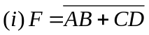using CMOS logic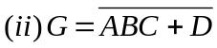 using NMOS logic  - Discuss IIL logic and its advantages over saturated logic. | 8  7
2. | - Analyze the DTL circuit shown. Determine the approximate relationship to determine the fan out of the gate.  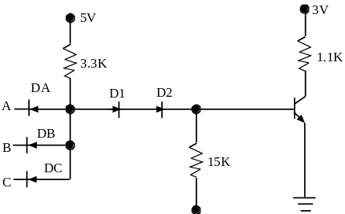  - The TTL gate is shown in figure. Explain its operation. Also discuss the use of the totem-pole pair, multiemitter transistor and the diode in the circuit.  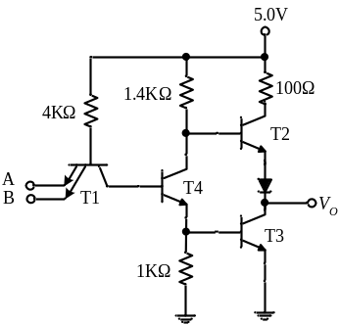 | 7  8
3. | - Draw and explain the circuit used to translate the level from saturated logic to ECL.  - A CMOS inverter circuit is given in Figure. If V_{SS} = 10V, V_{T}(n) = V_{T}(p) = 2V, draw the input-output voltage characteristics supporting with necessary derivations.  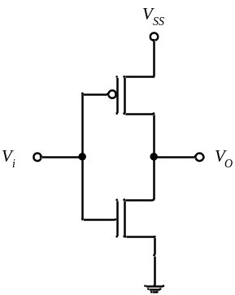 | 7  8
4. | - Why is the CMOS switching speed is grater than PMOS/NMOS?  - Draw a six transistor static MOS memory cell and explain how the bit is stored in the cell. | 7  8
5. | - Compare CCD with CMOS memory devices.  - 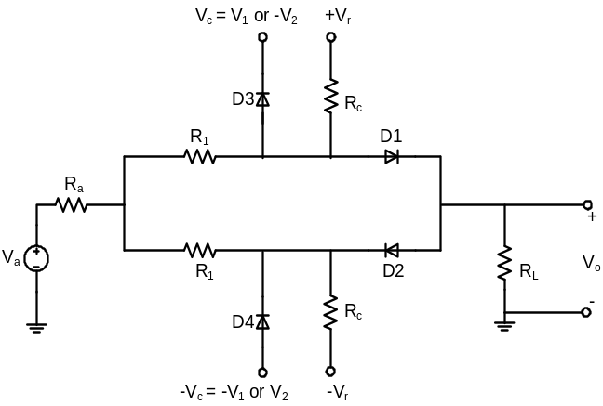Explain the operation of the four diode transmission gate shown in figure.  [7] | 7  8
6. | - With neat labeled circuit diagram explain any one application of analog switch.  - What is an entity of VHDL? Write the VHDL code of digital entities for 2-4 decoder.  - Write down the VHDL code for a 4:1 multiplexor. | 5  5  5
7. | Write short notes on (Any Two):  - FET Gate drivers  - RTL XOR  - Logic level diagram | 2×5

